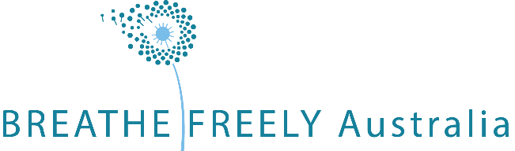

OPERATIONAL ORGANISATIONS

Organisations - Support the Breathe Freely Australia Campaign

This form is for operational organisations that are committed to making a difference and protecting workers’ health. This category of Supporter applies to organisations which have operations where the work can generate atmospheric contaminants (eg welding, sawing, cutting, drilling, pressurised spraying) or any industrial activity with potential to put chemical agents into the breathing zone of operators or by-standers.

By signing up as a Supporter, you and your organisation are demonstrating your leadership and your organisation’s commitment to protecting the lives of workers in your operations.

Breathe Freely Australia – Supporter’s Pledge

My organisation commits to:
1. Assess which work activities have the potential to cause dust-related occupational lung diseases
2. Develop and deliver a preventive plan to eliminate or reduce the risks of developing dust-related occupational lung diseases.
3. Educate managers to understand risks of dust-related occupational lung diseases and to manage them proactively as a significant health issue
4. Consult with employees to ensure they use the preventive measures appropriately, and check the effectiveness of preventive measures through provision of health monitoring, if needed.
The Breathe Freely Australia Supporter’s Pledge is aimed at capturing the key actions your organisation is already doing to manage dust-related occupational lung disease exposures within your workplace.

Tailor your pledge by expanding on the points relevant to your organisation. Please use the points below to provide guidance in your response. Download the word document, complete your pledge and submit it electronically at bfa@aioh.org.au

You can request a Breathe Freely Australia Supporters Certificate demonstrating your commitment – we’ll need to review your pledge first. We will add your name and logo to the Supporters Page of the Breathe Freely Australia website, unless you request otherwise.
The Breathe Freely Australia Supporter’s Pledge Form

This form aims to capture the key actions your organisation has implemented to manage dust-related occupational lung diseases exposures within your workplaces.

You can tailor your pledge by expanding on the points relevant to your organisation. Please use the points below to provide guidance in your response.
When completed, please send to bfa@aioh.org.au

- Assess which work activities have the potential to cause dust-related lung diseases
Your first step should be to find out if your work could expose workers or others to the risks of
developing occupational lung diseases and to assess the possible extent of exposure.

Please identify the following:
- Sources of dust exposure in your workplace.
- Work activities causing dust exposure and what measures are currently in place to minimise dust exposures.

- Develop and deliver a prevention strategy to eliminate or reduce the risks of developing dust-related occupational lung diseases
Next, you should put measures in place to protect workers against relevant dust exposure risks.

Please let us know what you’re currently doing, or plan to do in areas such as:
- Create a prevention plan that reflects legislation and current good practice to reduce exposures.
- Set exposure reduction targets or milestones as part of your plan and associated action plans.

- Educate managers to understand risks of dust-related occupational lung diseases and manage them proactively as a significant health issue.

Managers at all levels need to understand the issue as part of their legal, occupational safety and health duty of care.

Please let us know what you’re currently doing to:
- Brief your managers about what can cause occupational lung diseases in your workplace and what you need to do as an organisation to prevent health effects.

- Consult with your employees to ensure they use the preventive measures appropriately, and check the effectiveness of preventive measures through provision of health monitoring.

Ensure employees understand why preventive measures are needed, and check that the exposure reduction plan is working. To help you communicate with employees, visit https://www.breathefreelyaustralia.org.au/ to download free resources, including presentations.

Please let us know what you’re currently doing to:
- Engage your employees and increase their understanding of the need for preventive measures, eg running toolbox talks on hazardous dusts for people at risk of exposure
- Provide health surveillance, where appropriate. Ensure that potential exposures are taken into account as part of your health surveillance programme
- Provide feedback to workers on dust control measures, and on their health surveillance results.

